**MIS 328**

**APPLIED OPERATIONS RESEARCH**

**SERVER QUEUE PROBLEM**

**BARIŞ İLGİN**

**MURAT DEMİRCİ**

**What is a queuing problem?**

A queue happens when there are more clients than employees to provide them. That means that customers must wait for their turn to enter.Whether the waiting itself is a problem or not may only be determined by the clients.

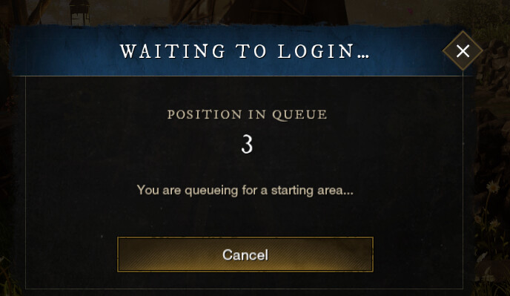**What is game server queue problem?**

About online server queue problems,it is not different at all.When there are many people who wants to enter the game exactly at the same time with other people it may cause a huge problem.If the game server does not have enough capacity of server,seeing a queue of waiting to enter the game is inevitable.

Nowadays there are lots of online games in our lives and this sector is growing years to years.So demand is increasing and usually server capacities are small compared to demand.This problem is very similar with real life queue problems.For example,in the supermarkets we may see lots of people in the queue and it may take lots of time to finish their shopping.There are several solutions to avoid this queue problem.In the super markets we can add more lines to make the queue less.It is also valid for the online server queue problems.Just one server may not be enough for the entry always.If we increase the number of server in the games,people will not have to wait for long times to enter.

**SERVER ERRORS**

If a game does not have enough multiplayer games in a country, region,or surrounding region, the server will not be opened there either.For example, in a game, Turkey's access to Europe is between 60-70 ms (Milliseconds).But if this server is in Turkey, the access will be around 15-20 ms,maybe even lower,and much faster access can be achieved.

**Encountering a server error in the game**

While playing a game or trying to send a message through a site.The higher the number in the “ms” value,the longer the time elapsed between the data coming out of our computer reaching the server and receiving information from there.

**Avoiding server error:**

First of all, the selected server must be a server with high performance.You need an adequate system as hardware.The system should not lose its responsiveness when many users visit the server at the same time. Another issue that needs attention is the lag of the server in the games.Latency is the time it takes for the player to reach the server and get the response back to the player.While choosing a server in the games, more than one different server is looked at. The most important thing that the player should pay attention to when choosing a server is the location of the server. In games played in Turkey or abroad, a server of foreign origin should not be preferred instead of the country played.

**To set up a game server:**

In order for the game to run,we must choose the appropriate operating system. For example, while some games support linux, both windows and Mac, some games will be more selective in this regard. In addition to the operating system, we should make our distribution choice in accordance with the game.We can summarize the common points for each distribution as follows.First of all,we must install a programming language on your server and update the installation. Then you have to download the game files.All that remains is to run this file with the programming language we installed.However, different installations take place in the installation of some games.